课程代码（Coursenumber）
Chemistry 3570 (357)
课程对象（Audience）
Primarily for Undergraduates
开课教师（Teacher）
Professor Njarðarson
学期（Semester）
Fall
课程描述（Description））
This is a support website, which provides plenty of practice problems and other useful features that should prove helpful for the course. We have convinced the publisher to also include access code to this website in the bundle you can buy at the bookstore. The publisher (Pearson Prentice Hall) has created a custom website for the textbook (http://www.pearsoncustom.com/ny/cornell_chemistry/), which gives students dual
access to both the companion website for the Bruice text and ACE Organic. If you are
interested, you can purchase an access code by going to this website and select “Get Access”.
课程提纲（Syllabus）
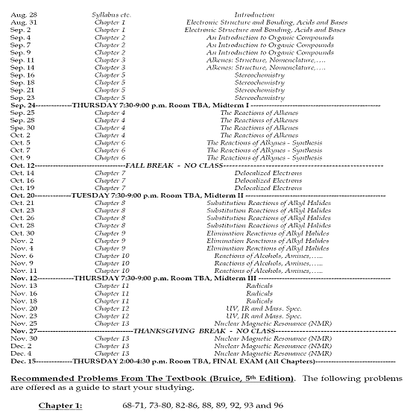
课时信息（Totalhours）
教参信息（Textbookinfo）
1 Chemistry: Concepts and Problems: A Self-Teaching Guide (Wiley Self-Teaching Guides) by Clifford C. Houk and Richard Post (Paperback - Feb 1996)
ISBN-13: 978-0471121206
2. Chemistry by Steven S. Zumdahl and Susan A. Zumdahl (Hardcover - Dec 3, 2008)
ISBN-13: 978-0547125329
世界各地拥有馆藏的图书馆（OCLC）:55
3.Chemistry for Dummies by John T. Moore (Paperback - Nov 2002)
ISBN-13: 978-0764554308
世界各地拥有馆藏的图书馆（OCLC）:1240
4.Homework Helpers: Chemistry by Greg Curran (Paperback - Mar 2004) ISBN-13: 978-1564147219
世界各地拥有馆藏的图书馆（OCLC）:19
5.Chemistry: The Central Science (11th Edition) by Theodore E. Brown, H. Eugene LeMay, Bruce E. Bursten, and Catherine Murphy (Hardcover - Jan 8, 2008)
ISBN-13: 978-0136006176
世界各地拥有馆藏的图书馆（OCLC）:164
6.The Cartoon Guide to Chemistry (Cartoon Guide To...) by Larry Gonick and Craig Criddle (Paperback - May 3, 2005)
ISBN-13: 978-0060936778
世界各地拥有馆藏的图书馆（OCLC）:1143
7.General Chemistry by Linus Pauling (Paperback - Apr 1, 1988)
ISBN-13: 978-0486656229
8.The Complete Idiot's Guide to Chemistry, 2nd Edition by Ian Guch (Paperback - Jun 27, 2006)
ISBN-13: 978-1592575145
世界各地拥有馆藏的图书馆（OCLC）:526
9.Chemistry: An Introduction to General, Organic, & Biological Chemistry (10th Edition) by Karen Timberlake (Hardcover - Feb 18, 2008)
ISBN-13: 978-0136019701
世界各地拥有馆藏的图书馆（OCLC）:113
10.Chemistry by Steven S. Zumdahl and Susan A. Zumdahl (Hardcover - Jan 9, 2006)
ISBN-13: 978-0618528448
世界各地拥有馆藏的图书馆（OCLC）:65

