课程代码（Coursenumber）
Chemistry 3000 (300)
课程对象（Audience）
Primarily for Undergraduates
开课教师（Teacher）
Professor Marohn
学期（Semester）
Fall
课程描述（Description））
Chemistry 3000, Quantitative Chemistry, is the first course in the Integrated Laboratory Sequence required of chemistry majors at Cornell University. There are two main goals for the course. The first goal is to introduce you to techniques for quantifying the amount of a chemical in a potentially complex sample to within a few percent or better. The second is to introduce you to the idea of error analysis and how to design experiments that give you the most accurate information in the least amount of time. The course consists mainly of one four-hour laboratory per week. See Table 1 on page ii for a schedule of experiments and required pre-laboratory reading assignments.
You will carry out six experiments this semester, lasting from 1/2 a period to 3 periods each. A pre-laboratory exercise (e.g., homework) will generally be assigned, due at the beginning of each laboratory period. You will turn in copies of your laboratory notebook pages each day and, after completing each experiment, will submit an analysis and discussion of the experiment’s data. You will be graded on the quality of your lab notebook entries, the depth of your thinking and analysis, and the accuracy and precision of your results. There will be no preliminary exam. In lieu of a final exam, there will be a comprehensive final project. In support of the laboratory there is a one-hour lecture per week. A lecture schedule, and suggested pre-lecture textbook readings, can be found in Table 2 on page iii. The purpose of the lectures is to explain how the experiments work (with demonstrations), to derive underlying concepts such as error analysis and curve fitting, and to carry out example calculations.
课程提纲（Syllabus）
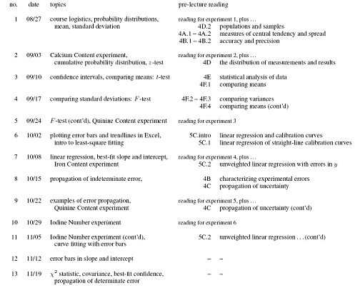
课时信息（Totalhours）
教参信息（Textbookinfo）
1 Density Functional Theory: A Practical Introduction - Hardcover (Apr. 13, 2009) by David Sholl and Janice A Steckel
ISBN-13: 978-0470373170
世界各地拥有馆藏的图书馆（OCLC）:118
2 Computational Chemistry: Introduction to the Theory and Applications of Molecular and Quantum Mechanics - Paperback (June 1, 2010) by Errol G. Lewars
ISBN-13: 978-9048138616
世界各地拥有馆藏的图书馆（OCLC）:2
3 A Chemist's Guide to Density Functional Theory, 2nd Edition - Paperback (July 11, 2001) by Wolfram Koch and Max C. Holthausen
ISBN-13: 978-3527303724
世界各地拥有馆藏的图书馆（OCLC）:247
4 Electrons and Phonons in Semiconductor Multilayers - Hardcover (May 25, 2009) by B. K. Ridley
ISBN-13: 978-0521516273
世界各地拥有馆藏的图书馆（OCLC）:123
5 Adventures in Chemical Physics: A Special Volume of Advances in Chemical Physics - Hardcover (Nov. 25, 2005) by R. Stephen Berry, Joshua Jortner, and Stuart A. Rice
ISBN-13: 978-0471738428
世界各地拥有馆藏的图书馆（OCLC）:121

