课程代码（Coursenumber）
CHEM 3580
课程对象（Audience）
Primarily for Undergraduates
开课教师（Teacher）
Professor Sogah
学期（Semester）
Spring
课程描述（Description）
Chemistry 3580 continues the systematic exploration of organic chemistry begun in Chem 3570. The course will explore structure, synthesis, and reactions of organic compounds with special emphasis on mechanisms. Applications to molecules relevant to life sciences will be explored. The skills you developed in Chem 3570 – arrow pushing, three dimensional visualization, drawing skills, organization and integration of facts, and logical analysis – are essential in solving homework and examination problems and will be further developed in Chem 3580. In general, these skills are more important than the traditional rote memorization and formula-based approaches.
课程提纲（Syllabus）
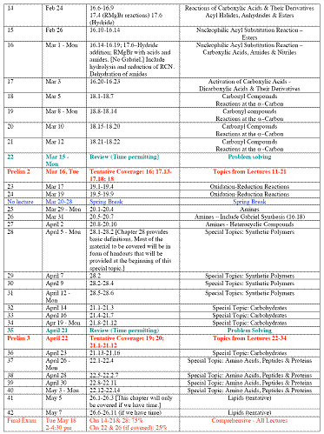
课时信息（Totalhours）
16312 LEC 001 MWF 09:05AM - 09:55AM BKL 200 Sogah,D (dys2)
16314 LEC 002 MWF 10:10AM - 11:00AM BKL 200 Sogah,D (dys2)
教参信息（Textbookinfo）
Organic Chemistry (ISBN –9780558207779)
1 Organic Chemistry for the Life 1 Glencoe Science: An Introduction to the Life, Earth and Physical Sciences, Student Edition - Hardcover - Student Edition (June 17, 2002) by McGraw-Hill
ISBN-13: 978-0078306167
世界各地拥有馆藏的图书馆（OCLC）:17
2 Introduction to the Biology of Marine Life - Paperback (Mar. 14, 2008) by John F. Morrissey and James L. Sumich
ISBN-13: 978-0763753696
世界各地拥有馆藏的图书馆（OCLC）:66
3 Science: An Introduction to the Life, Earth, & Physical Sciences (Teacher Wraparound Edition) - Hardcover (May 1999)
ISBN-13: 978-0028283166
4 General, Organic, and Biological Chemistry: An Integrated Approach - Hardcover (Jan. 15, 2010) by Laura D. Frost, S. Todd Deal, and Karen C. Timberlake
ISBN-13: 978-0805381788
世界各地拥有馆藏的图书馆（OCLC）:16
5 Lymphatics (Colloquium Series on Integrated Systems Physiology: from Molecule to Function) - Paperback (July 31, 2010) by David Zawieja
ISBN-13: 978-1615040339
世界各地拥有馆藏的图书馆（OCLC）:2
6 Soil Carbon Dynamics: An Integrated Methodology - Hardcover (Feb. 15, 2010) by Werner L. Kutsch, Michael Bahn, and Andreas Heinemeyer
ISBN-13: 978-0521865616
世界各地拥有馆藏的图书馆（OCLC）:94
7 An Introduction to Predictive Maintenance, Second Edition (Plant Engineering) - Hardcover (Oct. 10, 2002) by R. Keith Mobley President and CEO of Integrated Systems Inc.
ISBN-13: 978-0750675314
世界各地拥有馆藏的图书馆（OCLC）:92
8 Study Guide for Heiman's Understanding Research Methods and Statistics: An Integrated Introduction for Psychology, 2nd - Paperback (Oct. 12, 2000) by Gary Heiman
ISBN-13: 978-0618043057
9 Microelectronic Processing: An Introduction to the Manufacture of Integrated Circuits (Mcgraw Hill Series in Electrical and Computer Engineering) - Hardcover (Feb. 1987) by Walter Scot Ruska
ISBN-13: 978-0070542808
10 Introduction to Accounting: An Integrated Approach/Annual Report Booklet to Accompany Introduction to Accounting : An Integrated Approach - Hardcover (Nov. 1996) by Penne Ainsworth, Deines, Plumlee, and Larson
ISBN-13: 978-0256234220
11 Introduction to Product/Service-System Design - Hardcover (Dec. 1, 2009) by Tomohiko Sakao and Mattias Lindahl
ISBN-13: 978-1848829084
世界各地拥有馆藏的图书馆（OCLC）:16

